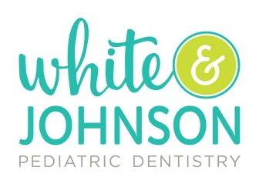
OCR NOTICE OF NONDISCRIMINATION

White & Johnson Pediatric Dentistry complies with applicable Federal civil rights laws and does not discriminate on the basis of race, color, national origin, age, disability, or sex. White & Johnson does not exclude people or treat them differently because of race, color, national origin, age, disability, or sex. White & Johnson Pediatric Dentistry provides free aids and services to people with disabilities to communicate effectively with us, such as:
- Qualified sign language interpreters
- Written information in other formats (large print, audio, accessible electronic formats)
Provides free language services to people whose primary language is not English, such as
- Qualified interpreters
- Information written in other languages
If you need these services, contact Lynn Stinson 910-686-1869 ext. 3 or April Oakes 910-333-0343 ext.4.
If you believe that White & Johnson has failed to provide these services or discriminated in another way on the basis of race, color, national origin, age, disability, or sex, you can file a grievance with
Lynn Stinson, 8115 Market Street – Ste 204, Wilmington, NC 28411
Phone: 910-686-1869 xt. 3 or Fax: 910 319-6014
You can file a grievance in person or by mail, fax, or email. If you need help filing a grievance, Lynn Stinson, Practice Manager at 910-686-1869 xt. 3 or April Oakes, Practice Manager at 910-333-0343 are available to help you.
You can also file a civil rights complaint with the U.S. Department of Health and Human Services, Office for Civil Rights electronically through the Office for Civil Rights Complaint Portal, available at https://ocrportal.hhs.gov/ocr/portal/lobby.jsf, or by mail or phone at: U.S. Department of Health and Human Services, 200 Independence Avenue SW. Room 509F, HHH Building Washington, DC 20201 Toll Free: 1-800-868-1019, 800-537-7697 (TDD). Complaint forms are available at http://www.hhs.gov/ocr/office/file/index.html.

